# VISVESVARAYA TECHNOLOGICAL UNIVERSITY

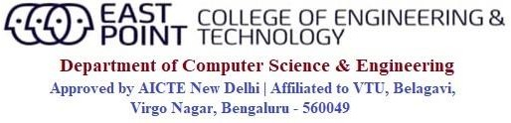

Jnana Sangama, Belagavi-590018

**An Internship(21INT49) Report on**

**“College Website Using HTML & CSS”**

***Submitted in partial fulfillment of the requirements for the award of degree of***

## BACHELOR OF ENGINEERING IN

**COMPUTER SCIENCE AND ENGINEERING**

## By

**Rupam Bhattacharyya 1EP21CS089**

|  |  |
| --- | --- |
| **Internal Guide:**  **Prof. Divya U H Associate Professor,**  **Dept. of CSE, EPCET** | **Company Guide:**  **Shubham Bansal**  **Software Engineer,**  **Google** |

**2022-2023**



**CERTIFICATE**

This is to certify that the Internship (21INT49) entitled “College Website using HTML & CSS” is a bonafide work carried out by **Rupam Bhattacharyya[1EP21CS089]**, in partial fulfillment of the requirements of BACHELOR OF ENGINEERING in COMPUTER SCIENCE AND ENGINEERING in VISVESVARAYA TECHNOLOGICAL UNIVERSITY, Belgaum, during the year 2022-2023. It is certified that corrections/suggestions recommended have been incorporated in the Internship report.

|  |  |  |  |
| --- | --- | --- | --- |
| **Internal Guide** | **Company Guide** | **Signature of HOD** | **Signature of Principal** |
| **Prof. Divya U H** | **Shubham Bansal** | **Dr. I Manimozhi** | **Dr. Mrityunjaya V Latte** |
| **Associate Professor,** | **Software Engineer,** | **HOD, Dept. of CSE,** | **Principal,** |
| **Dept. of CSE, EPCET,**  **Bangalore.** | **LearnTube** | **EPCET, Bangalore** | **EPCET, Bangalore** |

### Reviewers:

**Reviewer Panel Member**

### Name: Prof. Shammi L Name: Dr. I Manimozhi

**Signature with date: Signature with date:**

# Certificate.jpeg

# ACKNOWLEDGEMENT

First and foremost, I would like to express my sincere regards and thanks to **Management** of **East Point Group of Institutions, Bengaluru** for providing me an opportunity to work on this Internship.

I am ineffably indebted to **Dr. S Prakash, Senior Vice President**, **East Point Group of Institutions,** for his conscientious guidance and encouragement to accomplish this Internship.

I would like to express my humble and sincere thanks to **Dr. Mrityunjaya V Latte, Principal, East Point College of Engineering and Technology** for his suggestions that motivated me for the successful completion of my Internship.

I would like to express my heartfelt thanks to **Dr. I Manimozhi**, **Professor and Head of Department** of Computer Science and Engineering, EPCET for her valuable advice and suggestions to do my best in this Internship.

I am obliged to guide **Prof Divya U H**, Assistant Professor, Dept. of CSE, Internship Coordinators **Prof. Madhushree**, Assistant Professor, Dept. of CSE and **Prof. Nithyananda C R,** Associate Professor, Dept. of CSE who have rendered valuable assistance and guidance for the Internship.

I would like to thank **Mr. Shubham Bansal**, Software Engineer, LearnTube for providing with technical support and knowledge.

I would like to thank my **Parents** and **Friends** for their support and encouragement during the course of my Internship. Finally, I offer my regards to all the **Faculty members of the CSE Department** and all those who supported me in any respect during the Internship.

**Rupam Bhattacharyya[ 1EP21CS089 ]**

# CONTENTS

**Chapter no. Description Page no.**

1. Company Profile 1
2. About Company 2
3. Introduction 3
   1. Introduction to HTML 3
      1. Historical Perspective 4
      2. Understanding HTML Structure 4
      3. Basic HTML Elements 5

3..1.4 Document Structure & Nesting 5

* 1. Introduction to CSS 5
     1. A Historical Overview 5
     2. The Basic of CSS 6
     3. Selectors and Specificity 6
     4. Styling Properties and Values 7
     5. The Role Of CSS 8
  2. Implementation 9

1. Reflection 11
2. Conclusion 15

References 16

# Chapter 1

# COMPANY PROFILE

**Introduction**

LearnTube.ai is an innovative and cutting-edge technology company that specializes in creating advanced artificial intelligence-powered learning solutions. Established in 2016, the company's mission is to revolutionize education and training by leveraging the potential of AI to make learning more personalized, interactive, and accessible to learners of all ages and backgrounds. LearnTube.ai is committed to building a brighter future where everyone can acquire knowledge efficiently and effectively.

**Vision and Mission**

LearnTube.ai envisions a world where learning is not confined to traditional classrooms but is accessible to all, irrespective of geographical barriers or financial constraints. Their mission is to harness the power of AI and machine learning to create adaptive learning platforms that cater to individual learning styles, preferences, and pace. They aim to empower educators and learners alike with innovative tools and solutions, fostering a lifelong passion for learning.

**Key Services**

AI-Powered Learning Platforms: LearnTube.ai develops state-of-the-art learning platforms that utilize AI algorithms to analyze learner behaviors and preferences. This data-driven approach allows the platform to deliver personalized content and recommendations, ensuring a more engaging and effective learning experience.

Content Creation and Curation: The company also excels in content creation and curation, providing high-quality educational materials, including video lessons, interactive quizzes, and simulations. Their content is tailored to meet the specific requirements of different courses and subjects, making learning more enjoyable and effective.

# Chapter 2

**ABOUT COMPANY**

**Virtual Reality (VR) Learning**

Recognizing the immense potential of VR in education, LearnTube.ai has integrated virtual reality into their learning platforms. VR-based experiences enable learners to immerse themselves in realistic and interactive environments, enhancing their understanding and retention of complex concepts.

**Data Analytics and Insights**

LearnTube.ai emphasizes data-driven decision-making, leveraging advanced analytics to track learner progress, identify knowledge gaps, and refine their learning models. This data-centric approach allows educators to assess the effectiveness of their teaching methods and make necessary adjustments for better outcomes.

**Advantages and Innovations**

Personalized Learning Experience: By harnessing AI, LearnTube.ai provides learners with personalized learning paths, taking into account their strengths, weaknesses, and learning preferences. This adaptability fosters a deeper understanding of the material and promotes self-directed learning.

**Accessibility and Inclusivity**

The company is committed to making education accessible to all, including learners with disabilities or those from underserved communities. Their AI-powered platforms can accommodate diverse learning needs, breaking down barriers to education.

**Continuous Improvement**

LearnTube.ai places a strong emphasis on research and development. They continuously refine their AI algorithms and learning models based on user feedback and emerging trends in the educational technology space, ensuring that their products remain at the forefront of innovation.

# Chapter 3

# INTRODUCTION

**3.1 Introduction to HTML**

HTML, which stands for HyperText Markup Language, is the backbone of the World Wide Web. It is the standard markup language used to create web pages and is an essential skill for anyone involved in web development or content creation on the internet. In this comprehensive introduction to HTML, we will explore its history, structure, basic elements, and its role in shaping the digital landscape.

**3.1.1. Historical Perspective**

HTML has a rich history dating back to the early days of the internet. It was first proposed by Tim Berners-Lee in 1989, a British computer scientist who is credited with inventing the World Wide Web. HTML was created as a means to structure and organize the increasing amount of information available on the internet. The first version, HTML 1.0, was released in 1993. Since then, HTML has gone through several iterations, with HTML5 being the latest and most widely adopted version.

**3.1.2. Understanding HTML's Structure**

HTML is a markup language, which means it uses tags to define the structure and content of a webpage. These tags are enclosed in angle brackets < > and are used to create elements. An HTML document is composed of a series of nested elements that form a tree-like structure. Here's a basic outline of an HTML document:

<!DOCTYPE html>

<html>

<head>

<title>Document Title</title>

</head>

<body>

<h1>Heading 1</h1>

<p>This is a paragraph.</p>

<a href="https://www.example.com">Visit Example.com</a>

</body></html>

<!DOCTYPE html>: This declaration defines the document type and version of HTML being used. In this case, it's HTML5.

<html>: The root element that encloses the entire HTML document.

<head>: Contains metadata about the document, such as the page title.

<title>: Sets the title of the webpage, which appears in the browser's title bar or tab.

<body>: Contains the main content of the webpage.

<h1>: Defines a top-level heading.

<p>: Represents a paragraph of text.

<a>: Creates a hyperlink with the specified URL.

**3.1.3. Basic HTML Elements**

HTML provides a wide range of elements to structure content and add various types of media. Here are some of the most commonly used HTML elements:

Text Elements: These elements are used for creating and formatting text content.

<h1>, <h2>, <h3>, <h4>, <h5>, <h6>: Headings of decreasing importance.

<p>: Paragraphs of text.

<strong>: Indicates strong importance or emphasis.

<em>: Emphasizes text.

<br>: Inserts a line break.

<hr>: Creates a horizontal rule or line.

Links and Images: HTML allows you to include hyperlinks and images in your documents.

<a>: Creates hyperlinks to other webpages or resources.

<img>: Embeds images into the document.

Lists: HTML supports both ordered (numbered) and unordered (bulleted) lists.

<ul>: Defines an unordered list.

<ol>: Defines an ordered list.

<li>: Represents a list item within <ul> or <ol>.

Forms: HTML forms are used for user input and data submission.

<form>: Defines a form container.

<input>: Represents an input field.

<textarea>: Defines a multi-line text input area.

<button>: Creates a clickable button.

Tables: Tables are used for organizing data into rows and columns.

<table>: Defines a table.

<tr>: Represents a table row.

<th>: Defines a table header cell.

<td>: Represents a table data cell.

Semantic Elements: HTML5 introduced several semantic elements that describe the meaning of their content, aiding accessibility and search engine optimization.

<header>, <footer>, <nav>, <article>, <section>, <aside>, <main>, <figure>, <figcaption>, and more.

**3.1.4. Document Structure and Nesting**

HTML elements can be nested inside other elements, creating a hierarchical structure. Proper nesting is essential for maintaining the integrity and readability of your code. For example:

<div>

<p>This is a paragraph inside a div.</p>

<ul>

<li>Item 1</li>

<li>Item 2</li>

</ul>

</div>

In this example, the <ul> element is nested inside a <div> element, and <li> elements are nested within the <ul>. This clear hierarchy helps browsers and developers understand the structure of the document.

**3.1.5. The Role of HTML in Web Development**

HTML is the foundation of web development. While it defines the structure and content of a webpage, it works in conjunction with other technologies such as Cascading Style Sheets (CSS) for styling and JavaScript for interactivity. Together, these technologies enable developers to create dynamic and visually appealing web experiences.

CSS: CSS is used to control the presentation and layout of HTML elements. It allows developers to define styles like colors, fonts, margins, and positioning, making webpages aesthetically pleasing.

JavaScript: JavaScript is a programming language that adds interactivity to webpages. It enables actions like form validation, animations, and real-time updates without requiring page reloads.

Responsive Design: HTML plays a crucial role in creating responsive web designs. By structuring content with HTML5 semantic elements and using CSS media queries, websites can adapt to different screen sizes and devices.

Accessibility: HTML includes features like alt text for images and semantic elements to improve web accessibility. This ensures that websites are usable by people with disabilities.

**3.2 Introduction to CSS**

Cascading Style Sheets (CSS) is a cornerstone technology in web development, enabling designers and developers to define the visual presentation and layout of web content. This comprehensive introduction to CSS will delve into its history, its critical role in web design, selectors and properties, layout techniques, and its ongoing evolution.

**3.2.1 A Historical Overview**

CSS, which stands for Cascading Style Sheets, emerged as a response to the growing complexity of web content presentation. Before CSS, web designers had limited control over styling and layout, which led to inconsistent and often unattractive web pages. CSS was first proposed in 1994 by Håkon Wium Lie and Bert Bos as a means to separate the structure (HTML) from the presentation (CSS) of web documents. The first CSS specification, CSS1, was released in 1996, marking the beginning of a new era in web design. Since then, CSS has gone through several versions, with CSS3 being the most widely adopted version.

**3.2.2 The Basics of CSS**

At its core, CSS is a stylesheet language that allows you to define how HTML elements should be displayed on a web page. CSS achieves this by using a set of rules, each consisting of a selector and one or more properties and values. Here's a simple example:

/* CSS rule */

p {

color: blue;

font-size: 16px;

}

In this example:

p is the selector, which targets all <p> elements in the HTML document.

color and font-size are properties.

blue and 16px are values assigned to the properties.

This CSS rule instructs the browser to display all paragraphs in blue with a font size of 16 pixels.

**3.2.3 Selectors and Specificity**

CSS selectors are used to target specific HTML elements for styling. There are various types of selectors, including:

Element Selector: Selects all instances of a particular HTML element (e.g., p selects all <p> elements).

Class Selector: Selects elements with a specific class attribute (e.g., .highlight selects all elements with class="highlight").

ID Selector: Selects a single element with a unique ID attribute (e.g., #header selects the element with id="header").

Combination Selectors: You can combine selectors to target specific elements more precisely (e.g., ul.navbar li selects all <li> elements within a <ul> with class="navbar").

Pseudo-classes and Pseudo-elements: These allow you to target elements based on their state or position in the document (e.g., :hover selects an element when the mouse pointer is over it).

Specificity is a crucial concept in CSS. It determines which styles are applied when conflicting rules exist. Specificity is calculated based on the combination of selectors, IDs, classes, and element selectors in a CSS rule.

**3.2.4 Styling Properties and Values**

CSS provides an extensive list of properties and values to control nearly every aspect of a webpage's appearance. Here are some common properties:

Color Properties: color, background-color, border-color, etc.

Typography Properties: font-family, font-size, font-weight, line-height, etc.

Layout Properties: margin, padding, width, height, float, position, etc.

Box Model Properties: border, border-radius, box-shadow, outline, etc.

Transforms and Transitions: transform, transition, animation, etc.

Flexbox and Grid: Layout models for creating complex and responsive designs.

CSS is continually evolving, and new properties and values are introduced to keep up with the evolving needs of web design and development.

**3.2.5 The Role of CSS in Modern Web Design**

CSS is a fundamental tool in modern web design, playing a pivotal role in several key areas:

1. Responsive Design: CSS media queries allow designers to create layouts that adapt to different screen sizes and devices, providing an optimal user experience on both desktop and mobile.
2. Accessibility: CSS can be used to improve web accessibility by adjusting contrast, font size, and other visual elements to accommodate users with disabilities.
3. Animations and Interactivity: CSS animations and transitions add interactivity and engagement to web pages without the need for JavaScript.
4. Cross-Browser Compatibility: CSS helps ensure that web pages display consistently across various browsers and platforms, reducing compatibility issues.
5. Performance Optimization: Properly optimized CSS can improve page load times and overall performance by separating style from content. Changes can be made to the stylesheet without altering the HTML structure.

**3.3 Project Implementation**

body, h1, h2, p, ul, li { margin: 0; padding: 0;}

body { font-family: 'Arial', sans-serif; line-height: 1.6;}

header { background-color: #252525; color: #ffffff; padding: 20px 0; text-align: center;}

.navbar { display: flex; justify-content: space-between; align-items: center; padding: 0 20px; max-width: 1200px; margin: 0 auto;}

.logo img { height: 80px; width:350px;}

.nav-links li { display: inline; margin-left: 20px;}

nav-links a { text-decoration: none; color: #ffffff; font-weight: bold;}

.hero h1 { font-size: 36px; margin-bottom: 20px;}

.subheading { font-size: 18px; color: #ff9900; margin-bottom: 30px;}

.cta-button { display: inline-block; padding: 15px 30px; background-color: #ff9900; color: #ffffff;

text-decoration: none; border-radius: 4px; font-weight: bold;}

.about { background-color: #f4f4f4; padding: 100px 0; text-align: center;}

.about h2 { font-size: 28px; margin-bottom: 30px;}

about p { max-width: 800px; margin: 0 auto; font-size: 16px; line-height: 1.6; color: #555555;}

.courses { padding: 100px 0; text-align: center;}

.courses h2 { font-size: 28px; margin-bottom: 30px;}

.courses p { max-width: 800px; margin: 0 auto; font-size: 16px; line-height: 1.6; color: #555555;

margin-bottom: 40px;}

.testimonials {

background-color: #252525;

color: #ffffff;

padding: 100px 0;

text-align: center;

}

.testimonials h2 { font-size: 28px; margin-bottom: 30px;}

.testimonial { max-width: 600px; margin: 0 auto; padding: 20px; background-color: #333333;

border-radius: 4px; margin-bottom: 20px;}

.testimonial p { font-size: 16px; margin-bottom: 10px;}

.author { font-weight: bold;}

.footer { background-color: #252525; color: #ffffff; text-align: center; padding: 20px 0;}

body, h1, h2, h3, p, ul, li, label, input, select, textarea, button { margin: 0; padding: 0; border: 0;}

body { font-family: 'Arial', sans-serif; line-height: 1.6; color: #333333;}

.header { background-color: #252525; color: #ffffff; padding: 20px 0; text-align: center;}

.navbar { display: flex; justify-content: space-between; align-items: center; padding: 0 20px;

max-width: 1200px; margin: 0 auto;}

.logo img { height: 80px; width:350px;}

.nav-links li { display: inline; margin-left: 20px;}

.nav-links a { text-decoration: none; color: #ffffff; font-weight: bold;}

.application-form { max-width: 800px; margin: 40px auto; padding: 40px; text-align: center;}

.form-heading h1 { font-size: 36px; margin-bottom: 20px;}

.form-heading p { font-size: 18px; color: #777777; margin-bottom: 30px;}

.application-form form { text-align: left;}

.application-form label { display: block; font-size: 18px; margin-bottom: 10px;}

.application-form input,.application-form select,.application-form textarea { width: 100%; padding: 10px; margin-bottom: 20px; border: 1px solid #dddddd; border-radius: 4px; font-size: 16px;}

.application-form textarea { resize: vertical;}

.application-form button { display: inline-block; padding: 10px 20px; background-color: #ff9900;

color: #ffffff; text-decoration: none; border-radius: 4px; font-weight: bold; cursor: pointer;}

.footer { background-color: #252525; color: #ffffff; text-align: center; padding: 20px 0;}

# Chapter 4

**REFLECTION**

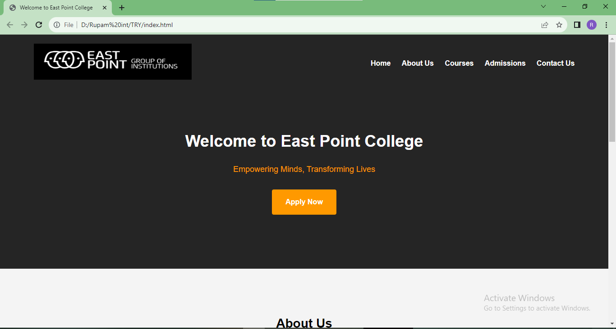

Figure 4.1 Home page

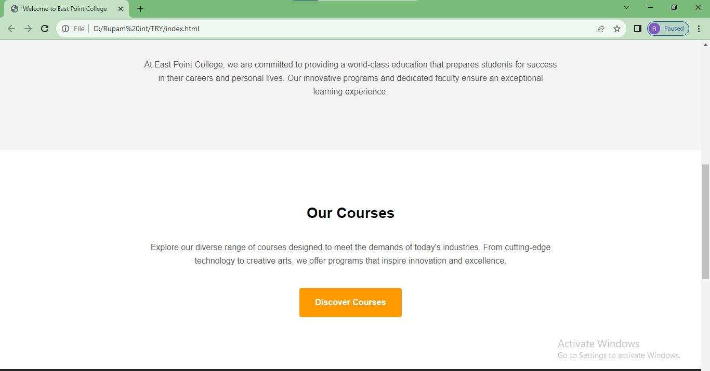

Figure 4.2 Home page courses

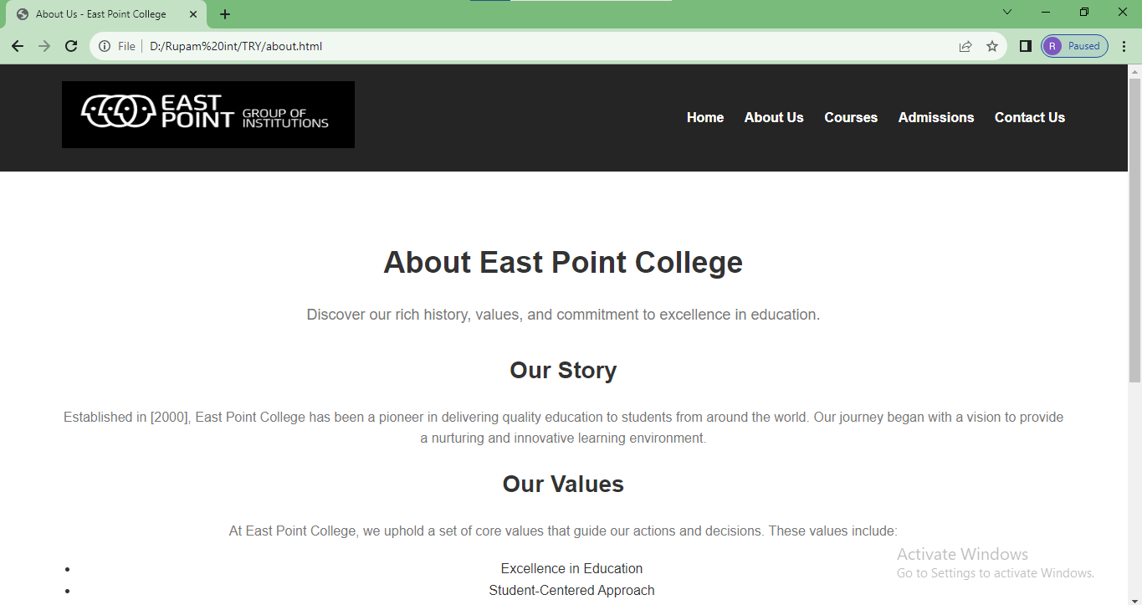

Figure 4.3 About us page

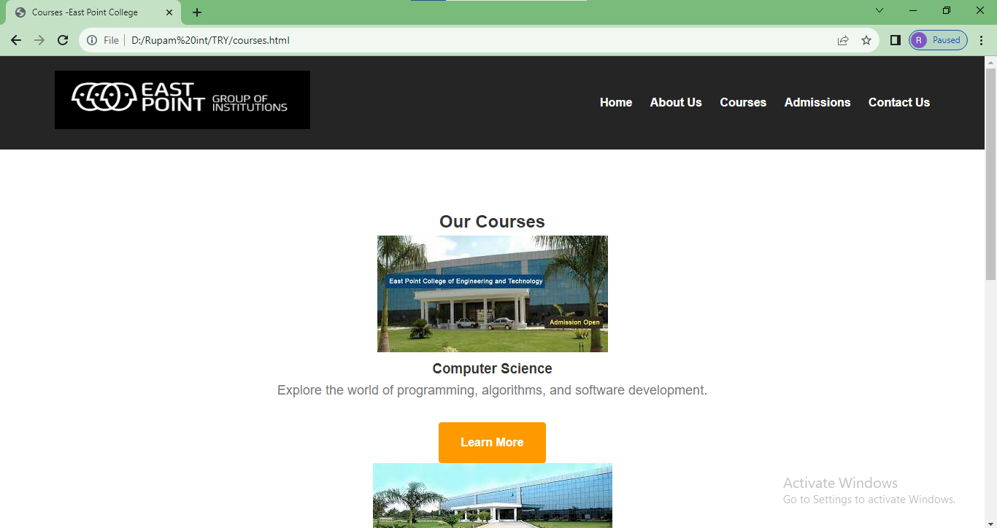

Figure 4.4 Courses page

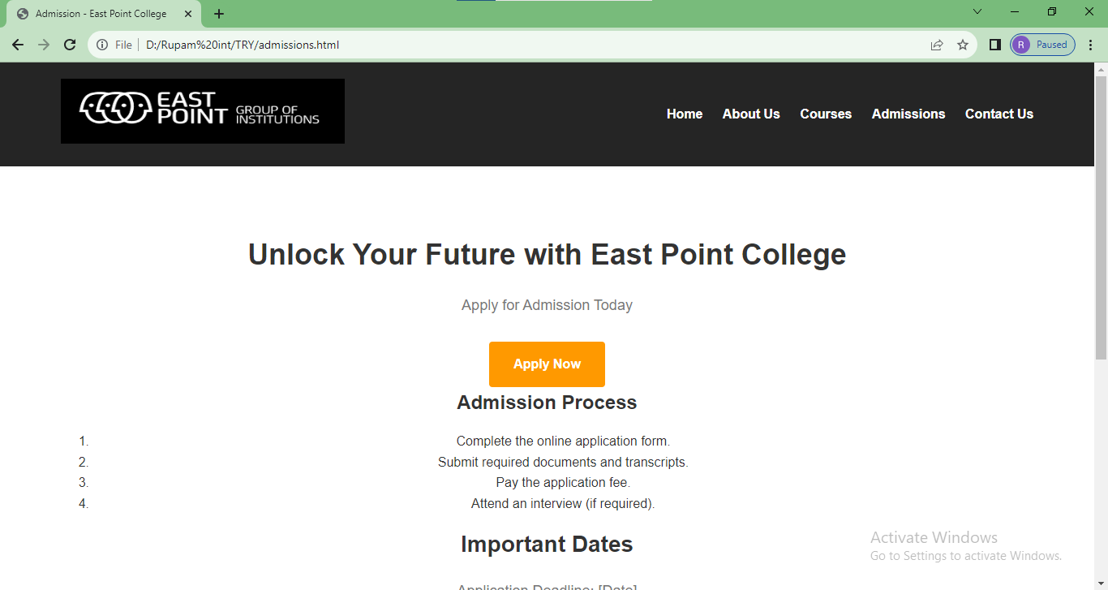

Fig 4.5 Admissions page

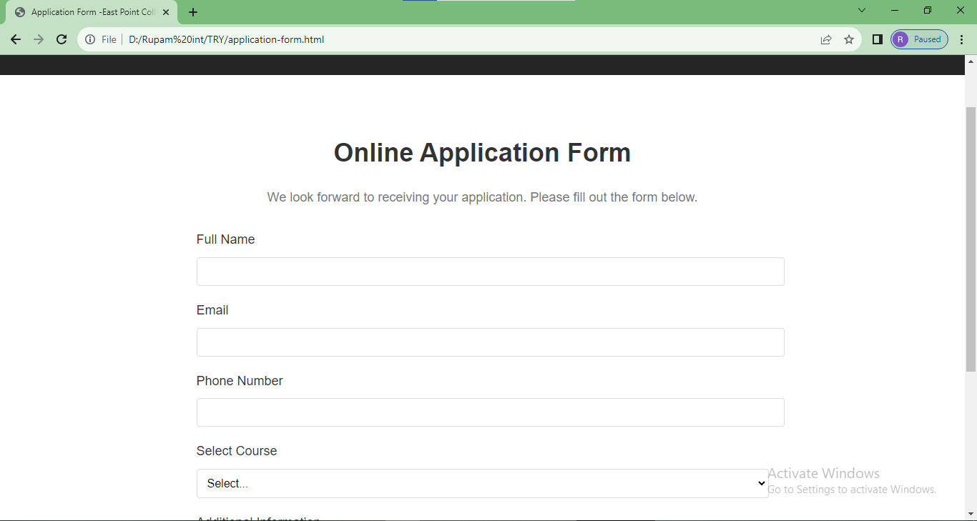

Figure 4.6 Application page

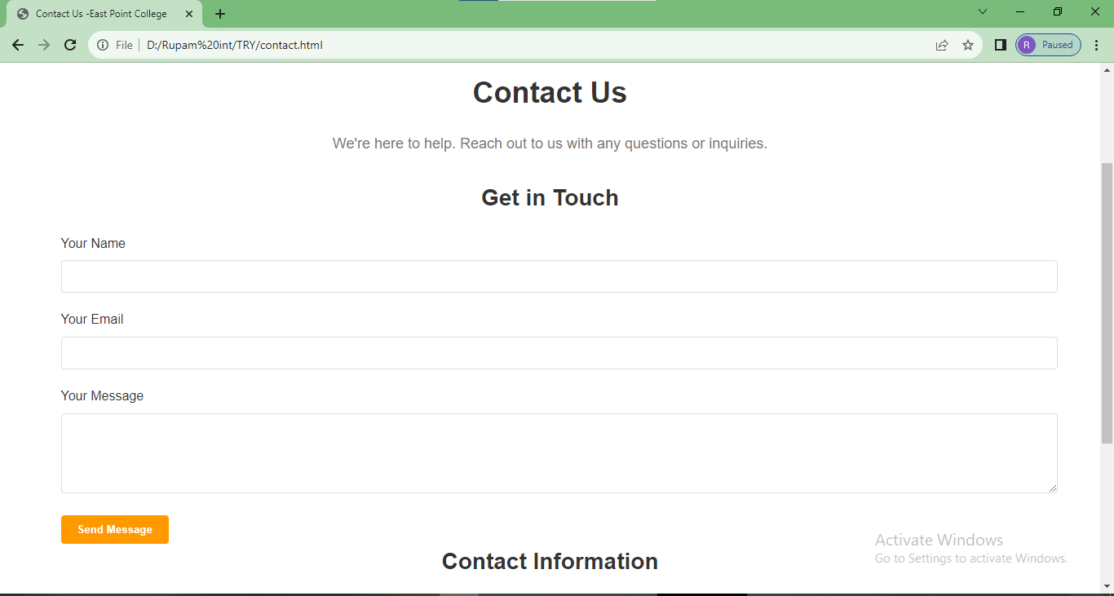

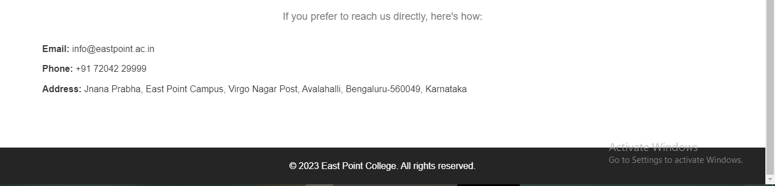

Figure 4.7 Contact us page

# Chapter 5

**CONCLUSION**

# The development of the college website using HTML and CSS marks a significant milestone in enhancing the online presence and user experience. Through careful design and implementation, a visually appealing and intuitive platform has been created, ensuring accessibility and responsiveness across various devices. CSS maintains a consistent and cohesive visual identity, while HTML provides the structural foundation for content. Moving forward, the commitment remains to regularly update and improve the website to meet the evolving needs of students, faculty, and visitors, ensuring it serves as an informative and engaging hub for all things related to the college community.

# Throughout this process, the importance of maintaining clean and organized code has been emphasized, enhancing the website's performance and facilitating future updates and modifications. By embracing best practices in web development, the college is better equipped to adapt to the ever-changing digital landscape and provide a seamless online experience to all stakeholders. The focus is on continuing the journey of web development and staying at the forefront of technology to deliver a user-centric, informative, and visually appealing website that truly reflects the essence of the college.

# 

# REFERENCES

1. MDN Web Docs - HTML: A comprehensive resource by Mozilla Developer Network (MDN) that covers HTML elements, attributes, and usage. https://developer.mozilla.org/en-US/docs/Web/HTML
2. MDN Web Docs - CSS: An in-depth guide by MDN on Cascading Style Sheets (CSS) properties, selectors, and techniques for styling web content. https://developer.mozilla.org/en-US/docs/Web/CSS
3. W3Schools - HTML Tutorial: A beginner-friendly tutorial that covers HTML basics, tags, and attributes, along with interactive examples. https://www.w3schools.com/html/
4. W3Schools - CSS Tutorial: A step-by-step guide on CSS styling, selectors, and responsive design, accompanied by hands-on examples. https://www.w3schools.com/css/
5. CSS-Tricks: A website with a wealth of articles, tutorials, and resources related to CSS, including advanced techniques, layouts, and animations. https://css-tricks.com/
6. A Book Apart - "HTML & CSS: Design and Build Websites" by Jon Duckett: This well-regarded book provides a comprehensive introduction to HTML and CSS, emphasizing design principles and best practices. https://abookapart.com/products/html-css